

**ADDIS ABABA UNIVERSITY**

**ADDIS ABABA INSTITUTE OF TECHNOLOGY**

**CENTER OF INFORMATION TECHNOLOGY AND SCIENTIFIC COMPUTING**

**DEPARTMENT OF SOFTWARE ENGINEERING**

**ASSIGNMENT 1: HISTORY OF INTERNET ASSIGNMENT**

Submitted By: Mekides Getahun

ID No: ETR/3218/11

Submitted To: Mr. Fitsum Alemu

March 2020

History of Internet

The Internet is at once a world-wide broadcasting capability, a mechanism for information dissemination, and a medium for collaboration and interaction between individuals and their computers without regard for geographic location.It has revolutionized the computer and communications world like nothing before.

The first recorded description of the social interactions that could be enabled through networking was a series of memos written by J.C.R. Licklider of MIT in August 1962 discussing his “Galactic Network” concept. He envisioned a globally interconnected set of computers through which everyone could quickly access data and programs from any site.

The Internet had its roots during the 1960's as a project of the United States government's Department of Defense, to create a non-centralized network.

This project was called ARPANET (Advanced Research Projects Agency Network),

created by the Pentagon's Advanced Research Projects Agency established in October 29, 1969 to provide a secure and survivable communications network for organizations engaged in defense-related research.

ARPA brought Larry Roberts, an old friend of Kleinrock's MIT, to manage the ARPANET project. Roberts turned to the work of British computer scientist Donald Davies and American Paul Baran for the data transport techniques they had invented.

He based the network on a brand-new concept called packet-switching," and thanks in large part to this choice, the ARPAnet would eventually morph into the modern internet.

ARPANET delivered its first message: a “node-to-node” communication from one computer to another. (The first computer was located in a research lab at UCLA and the second was at Stanford; each one was the size of a small house.) The message “LOGIN” was short and simple, but it crashed the fledgling ARPA network anyway: The Stanford computer only received the note’s first two letters.

In order to make the network more global a new sophisticated and standard protocol was needed. They developed IP (Internet Protocol) technology which defined how electronic messages were packaged, addressed, and sent over the network in the 1970s.

In 1973, Robert Kahn and Vinton Cerf [collaborate to develop a protocol](https://georgewbush-whitehouse.archives.gov/government/cerf-kahn-bio.html" \t "https://online.jefferson.edu/communications/internet-history-timeline/_blank" \o "Dr. Vinton Cerf and Dr. Robert Kahn: Medal of Freedom Recipients) for linking multiple networks together. This later becomes the Transmission Control Protocol/Internet Protocol (TCP/IP), a technology that links multiple networks together such that, if one network is brought down, the others do not collapse. While working at Xerox, Robert Metcalfe develops a system using cables that allows for [transfer of more data over a network](http://www.biography.com/people/robert-metcalfe-9542201" \t "https://online.jefferson.edu/communications/internet-history-timeline/_blank" \o "Robert Metcalfe Biography). He names this system Alto Aloha, but it later becomes known as Ethernet.

The standard protocol was invented in 1977 and was called TCP/IP (Transmission Control Protocol/Internet Protocol). In 1982, the PhoneNet system is established and is connected to ARPANET and the first commercial network, Telenet. This broadens access to the internet and allows for email communication between multiple nations of the world.

ARPANET adopted TCP/IP on January 1, 1983, and from there researchers began to assemble the “network of networks” that became the modern Internet. TCP/IP allowed users to link various branches of other complex networks directly to the ARPANET, which soon came to be called the Internet.

Internet usage has exploded since 1995, when researchers first started tracking this statistic. Although estimates vary from the Internet having 1 billion to 1.5 billion users, everyone agrees that the Net has room for growth as the worldwide population tops 6 billion. we are now experiencing the fourth scientific revolution.

Observation for Facebook

Facebook is easily the largest social networking site in the world and one of the most widely used.It was founded in 2004 and have been four major redesigns.this documentation observe new changes through the several years it starts from 2006 .the home page looks like the next image before 14 years ago.

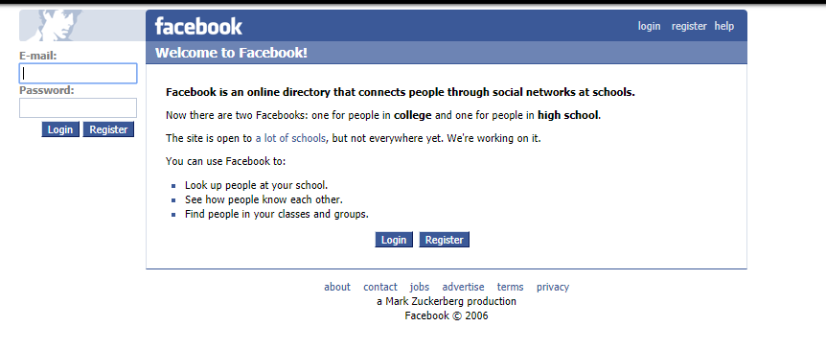

I observe they try to put some description about face book and made some buttons to register and log in to the page.on the other hand the spacing between lines was not equal and some wors are in bold font but not the others this disturb the user and the links of other pages are on the footer part of the page so not good pacing.

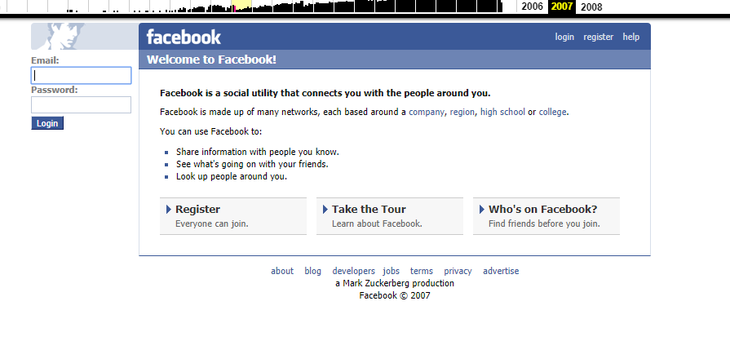

I observe their was a little change in 2007 Facebook web site.which is the word typed in bold reduces and some other useful buttons are added on body part.and add new other page or link of page on footer part but still it is on footer part.

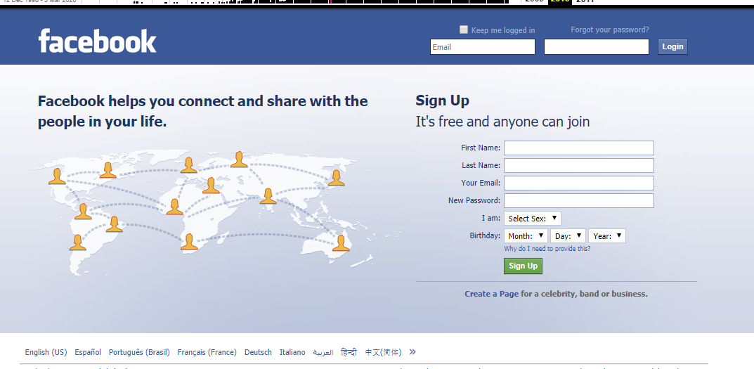

The above image shows the 2010 Facebook home page.their is a major change between the above.the text fields which takes name and email of user are at the top bar and have an option if the user forgot his password by click the link called “Forgot your password?” can get this password .and the left side image is bast ti express the use of face book.their are more questions user asked than before this is used to take accurate information about that person.the other best thing was to take a birthday of user they use the drag down menus and it was good for look.

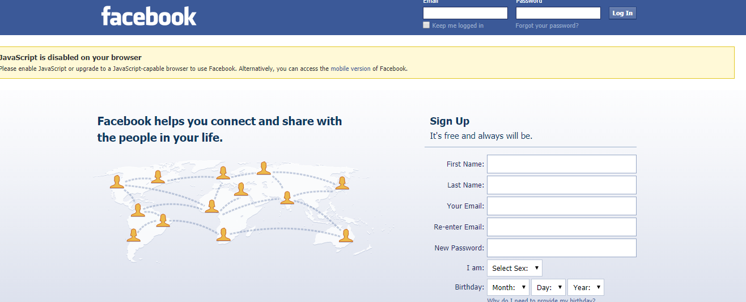

The above image is at 2017.and the major changes are on the top part of page the text files and link change the place the links are bottom of the fields that is the correct way because first must fill the field and then if it was not correct use the links to get new password.their is a new thing in yellow bar it gives an opportunity for use the mobile version of face book.

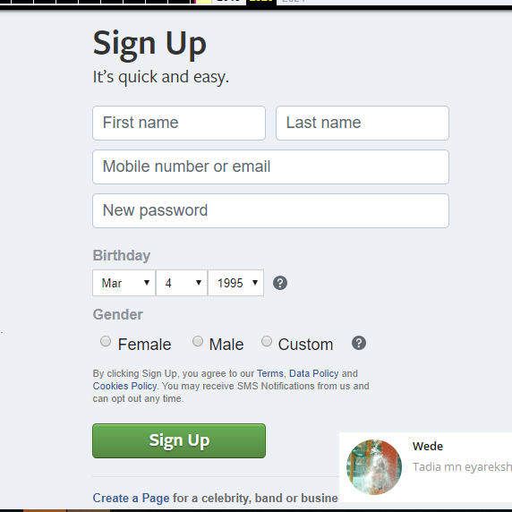

At 2019-20 the home page contains only the sign up page and it is so easy to fill or choose information.the spacing is so good

Observation on YouTube

It is an entertainment website and it allows billions of people to discover, watch and share originally-created videos with friends, family, and the world.relevance of youtube is the audience appears to be at least 18 years old and the Objectivity

YouTube is used to watch music videos, comedy shows, how to guides, recipes, hacks and Create playlists to organize videos and group videos together and more

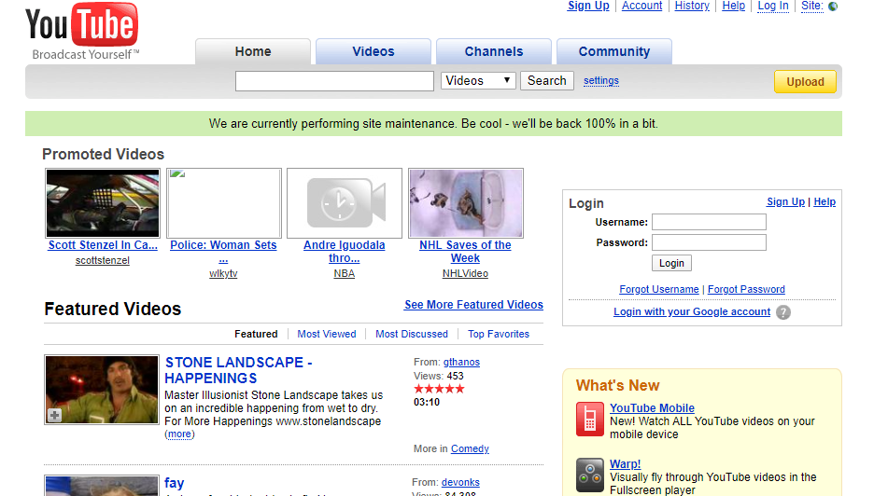

The above image shows the homepage of YouTube at 2008.I observe their are many blue word or links are their they are not comfortable to see and the spacing was really bad. the login field is not in good place I think it must be in the top because the user must see it first and the component are to much than the page space.the links of the other pages are on the right top part that and their is a drag down menu to choose what the user want to see.

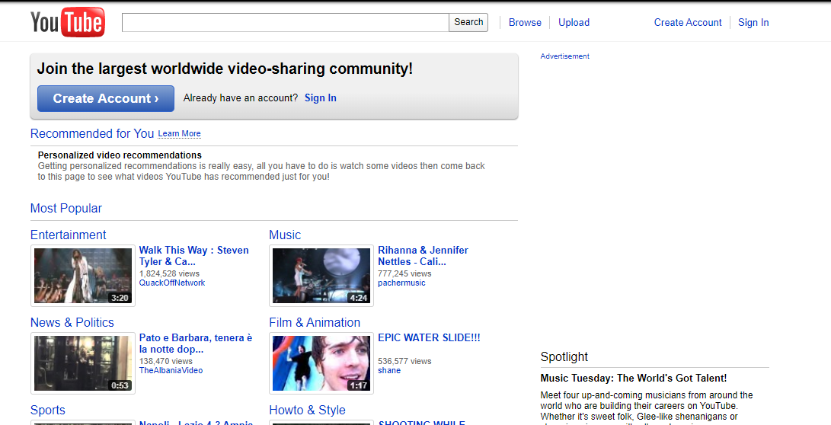

The above image shows the home page of you tube at 2011.their is a major change between the above.their is text filed that takes what user want to see and when the search button Is pressed it searches and found it.the spacing is goog than before.and their is a button called “create account” that is used to see the login page or login text fields so it is better to not to see directly the login page.and popular sites are o the top to get easily but still the blue lines are exist.

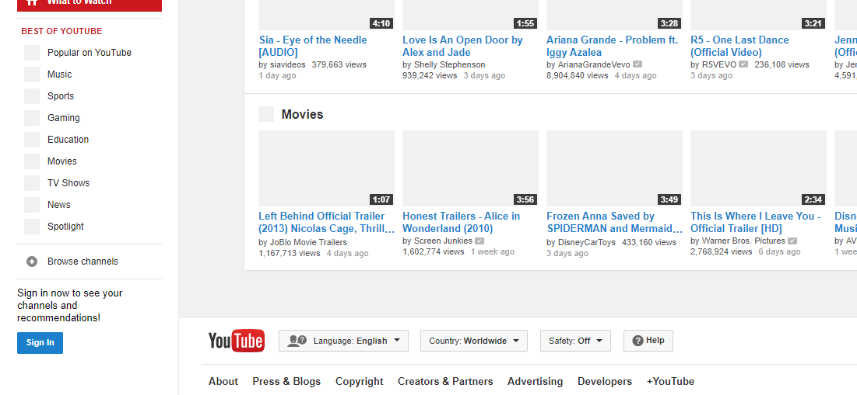

At 2014 the logo of you tube is at the bottom of the page that wasn’t good I prefer the logo put at the top.best of you tube lists are on the left side of the videos or music and the sign in button is bottom of it so the page is so simple to see and understand.the links of other pages comes to footer and their are grad downs to choose language and country to get more information.

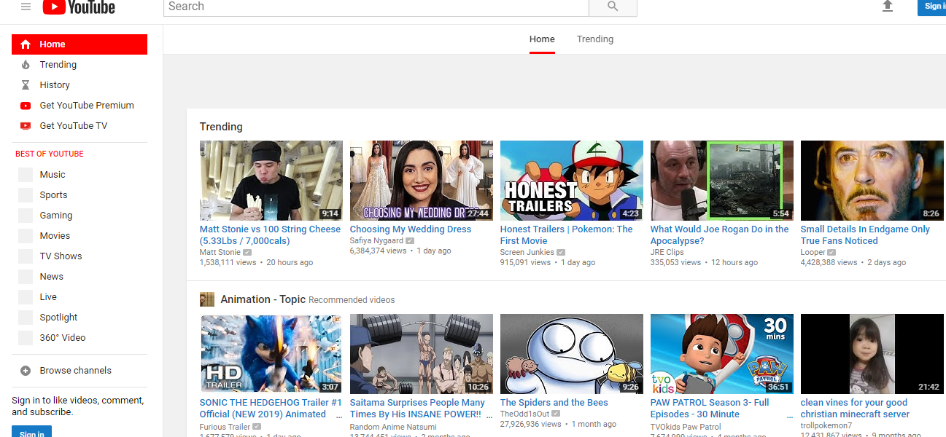

Their is no major change in 2019 but add some new links to best of you tube.

Observation on Google

I make observation on Google from the year of 2006.Accuracy of Google is We can drag and drop all you want and it all magically becomes responsive and allows you to create a website without having to know how to code it yourself.

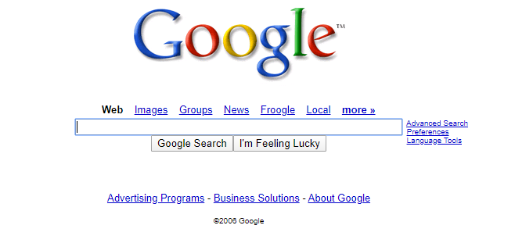 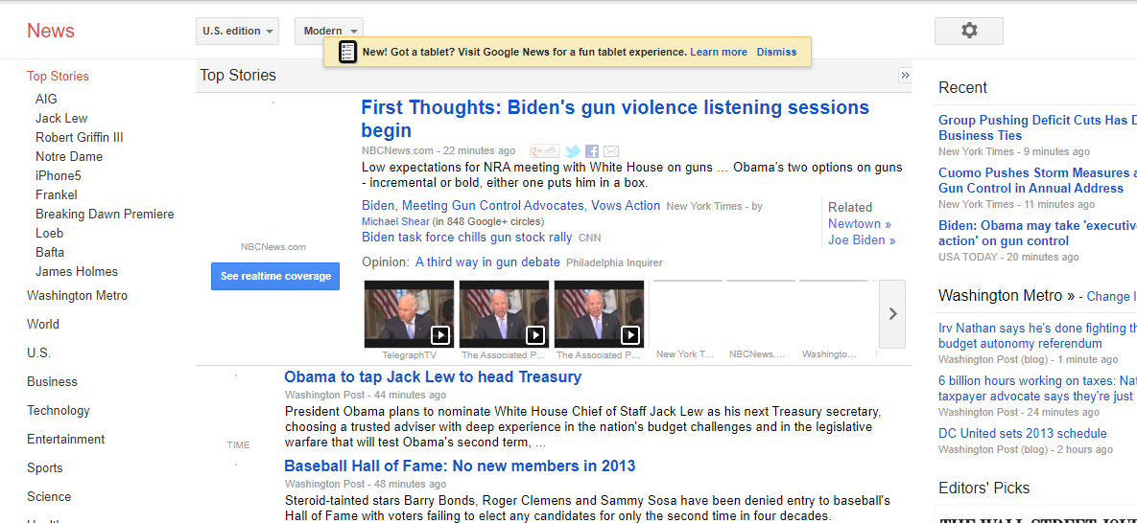

As the the above image shows the spacing is so poor and the links color is so bad.the good thing is the page is simple not much complicated. But the news page is so embedded with so many tings it needs some spacing but their are many links to get the news. And also the continuity is good because the home page and the others are the same background and lay out.

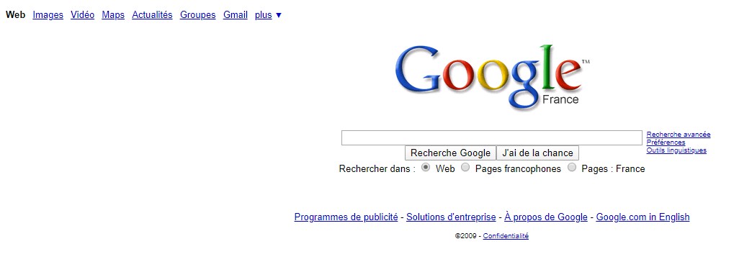

At 2009 the Google page is so boring. The spacing is still so bad and the blue line is still their.but the links of other pages are put at the top left side.

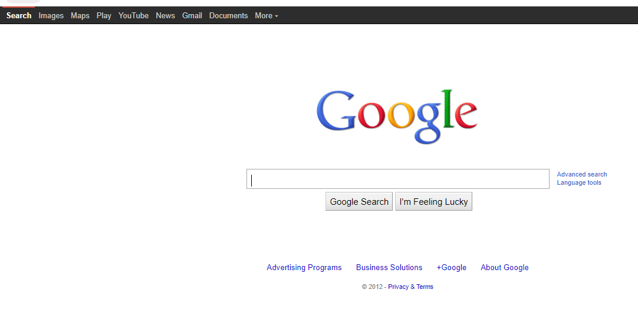

At 2012 the spacing was good and the blue color links are reduce and they are changed by the black bar.after this year their is no a big change on home page but in 2019 the news page looks like so better than the others the spacing is so good and their is no many blue line links.

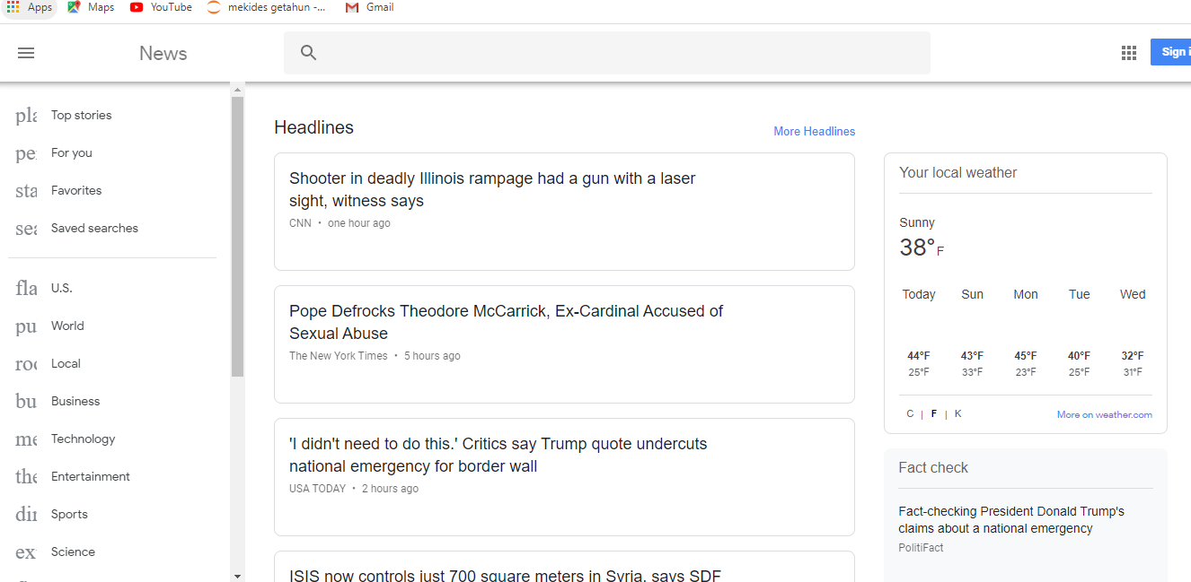

Observation on addis ababa university

I make an observation from 2005 to 2019.

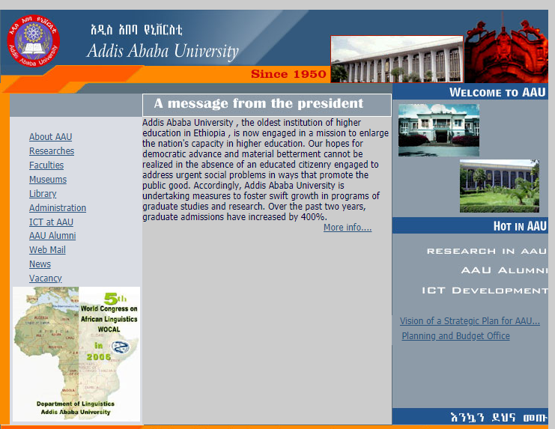

As the image shows it describe main information s about the univrsity but the spacing is so bad.

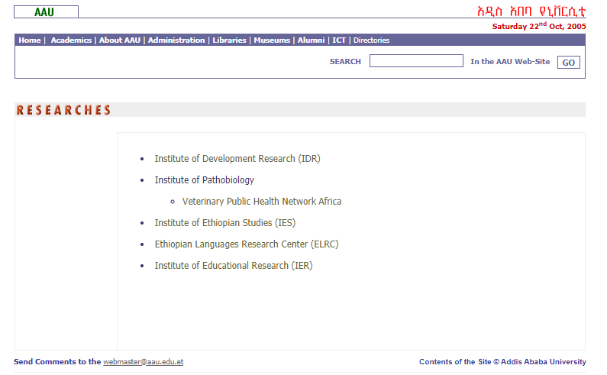 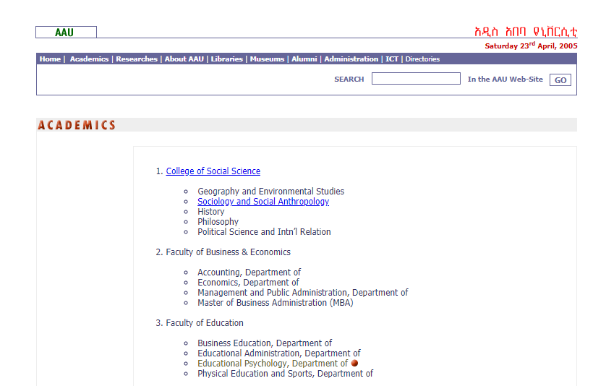

And the other pages are the same that is the good thing.

At 2008 tha page has some changes the home page have no more images.but the font and spacing is still so bad ande images are not good enough to load.

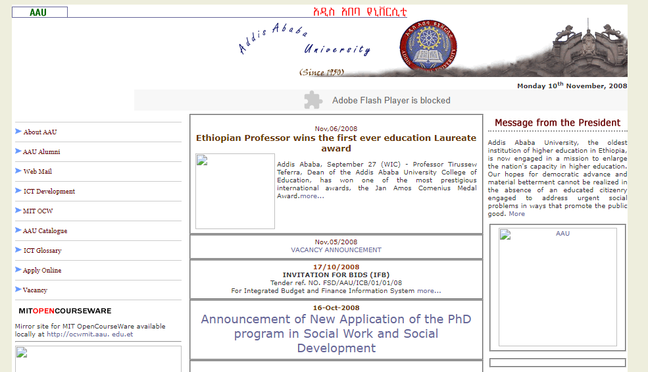

At 2013 the page is changed.

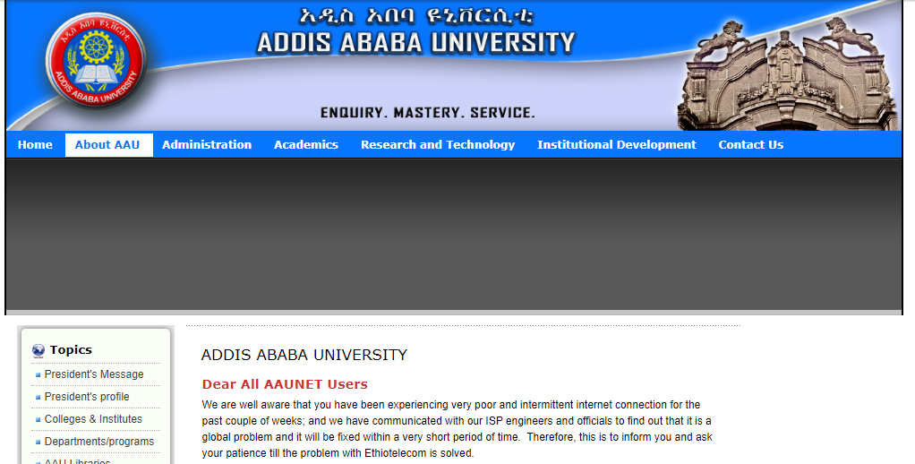 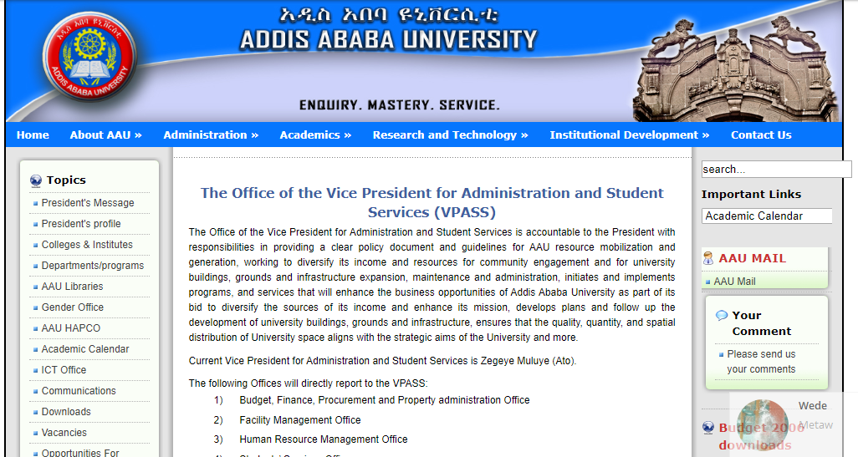

It is so good for spacing but description is to much that is not necessary. The other pages are the same with the home page but the search search text field is ou of the page.

At 2016 the page looks



The picture is changed to right and left but it takes a time and the search field is in good place and the drag down is also another good change.

At 2019 the page is almost the same to the above but the image chages with in seconds

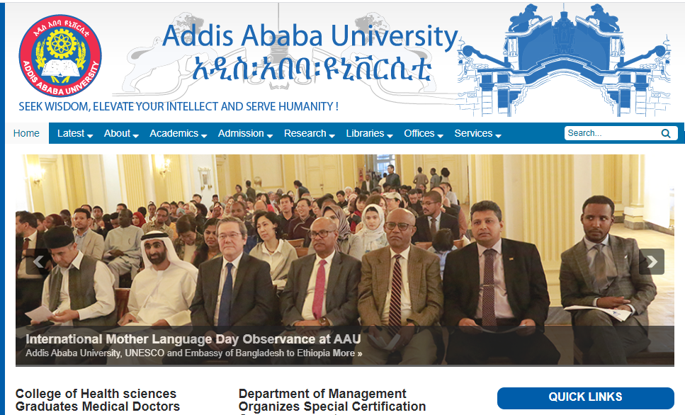 



## Types of websites and their examples

## As of now, there are billions of websites online, all competing for some share of the attention people give to their online browsing each day.Here are twelve of the most popular types of websites and their examples with their URLs.

* Educational website An educational Web site Provides information related to students , teachers and educational institutions.

## Examples of educational websites

1. EdX: edx.org  it was founded by Harvard University and the most uesful educational website to students
2. Academic Earth: academicearth.org

Is useful for academic options to student from traditional to contemporary studies.They provide online degree courses from accounting and economics to engineering

1. Futures Channel: thefutureschannel.com

this website is an educational channel for the learners,it is not just an online portal Unlike other websites, it only represent the significant data catering the problems faced by students. For example, students generally face problem in algebra, so they have created special section for the same.

1. Coursera: courser.org

It is a user-friendly website. Students can find big universities and a sharable electronic Course Certificate after completing the course. "Courses include recorded video lectures, and community discussion forums.

1. Brightstorm: brightstorm.com

High school scholars can use this site for reference. They provide help in all subjects from mathematics to science, history and other subjects. Entrance exams are generally quite gruelling for students, and this website can solve the problem.

* A content aggregator is an individual or organization that gathers Web content (and/or sometimes applications) from different online sources for reuse.

## Examples of A content aggregator website

The following sites are some of the best and most popular examples of successful content aggregator websites.

1. Alltop -<https://alltop.com/> founded by startup legend Guy Kawasaki, [Alltop](https://alltop.com/" \t "https://wpmayor.com/6-best-examples-content-aggregator-websites/_blank) is one of the biggest names in content aggregation. It allows a search for specific topics and then view aggregated content .
2. Popurls -<http://popurls.com/>

Popurls pulls in content from a variety of social networks, blogs, and news organizations Unlike Alltop, you can’t submit your own website to Popurls.

1. The Web List

[The Web List](http://theweblist.net/" \t "https://wpmayor.com/6-best-examples-content-aggregator-websites/_blank) functions similarly to Popurls in that it’s a one-page content aggregator website that collects content from a huge variety of sources

1. WP News Desk <http://wpnewsdesk.com/>

[WP News Desk](http://wpnewsdesk.com/" \t "https://wpmayor.com/6-best-examples-content-aggregator-websites/_blank) is a content aggregator website that focuses specifically on WordPress. It automatically pulls in content from a variety of WordPress blogs and companies and displays posts on the front page.

1. Travel Blogger Community

[Travel Blogger Community](http://travelbloggercommunity.com/" \t "https://wpmayor.com/6-best-examples-content-aggregator-websites/_blank) is for travel bloggers what WP News Desk is for WordPress. That is, Travel Blogger Community aggregates content from travel bloggers all around the world in one accessible place.

* An Informational Web site is one whose purpose is to present factual information. The URL Address frequently ends in .edu or .gov, as many of these pages are sponsored by educational institutions or government agencies. Examples: Dictionaries, thesauri, directories, transpor tation schedules, calendars of events, statistical data.

## Examples of informational websites

1. Hopmonk Tavern Informational Website - <https://zdca.com/project/hopmonk-tavern>

The owners of the North SF Bay Area’s top destinations for outstanding beer, food & unforgettable music had a clear idea of what makes a perfect website.As a result, they have got one site that unites 3 distinct locations, lots of interactive elements and custom graphics. These include self-sufficient navigation menus for each location with the huge galleries, menus, and information imported from the ticketing service to show info on the site so you do not need to enter the same place twice.

1. Mint – Informational Website Design <https://www.mint.com>

The website’s homepage shows secure and relaxing vibes, which is crucial for the financial firm. It also contains direct and simple call-to-action button .

1. Dropbox for Business Website website: https://www.dropbox.com/business

The design of the website is simple and user-friendly and the homepage is an excellent illustration of simplicity– you will see nothing but the shows important information that may really need by using huge image with simple and compelling copy.

1. Polygon Informational Website website: http://www.polygon.com

In this video game review website first thing is the correct use of the whitespace – nothing distracts the visitor from the important info. The unusual layouts and the text is accompanied by large and beautiful imagery.

1. Mosaic Art Now website: http://www.mosaicartnow.com

The website is full of meaningful content and plenty of interactive elements. That accommodates the amazing range of mosaic artists and arts.The website maintains trendy simplicity and user-friendliness, being very responsive to any screen size. The deep customization resulted in a varied content display.

* An entertainment Website - offers an interactive and engaging environment. Popular entertainment Web sites offer music, videos, sports, games, chat rooms.

Examples of entertenment website

1. YouTube - you tube.com

Founded in February 2005, allows billions of people to discover, watch and share originally created videos with friends, family, and the world. It provides a forum for people to connect, inform, and inspire others across the globe and acts as a distribution platform for original content creators and advertisers large and small.

1. The Worldwide Leader In Sports - [ESPN](http://espn.go.com/" \o "ESPN.com is the web extension of the mighty Entertainment and Sports Programming Network which provides comprehensive sports coverage since 1979." \t "https://blog.allmyfaves.com/tv/top-25-entertainment-sites-the-best-of-online-entertainment/_blank).com

It was launched in April 1995 .It provides complete sports information including [National Football League](https://en.wikipedia.org/wiki/National_Football_League" \o "National Football League) (NFL), [Major League Baseball](https://en.wikipedia.org/wiki/Major_League_Baseball" \o "Major League Baseball) (MLB),[National Basketball Association](https://en.wikipedia.org/wiki/National_Basketball_Association" \o "National Basketball Association) ( NBA), College Football, College Basketball scores and news. ESPN and [Women's sports](https://en.wikipedia.org/wiki/Women's_sports" \o "Women's sports) (ESPNW) Each section contains pages devoted to: scores, teams, schedules, standings, players, transactions, news wires, injures, and columnists pages.

1. Pandora - [http://pandora.com/](https://web.archive.org/web/2/http://pandora.com/)

[Pandora](https://www.howtogeek.com/365820/the-best-sites-for-streaming-free-music/pandora.com) is a great website to stream your favorite music and discover new music as well.As you enter your favorite genre or artist in the search box on the homepage, Pandora creates a radio station that includes music similar to your selection. Also it makes decisions about which music to recommend next.

1. Addictinggames - <https://www.addictinggames.com/>

Addictinggames is online free games website features a number of addicting and free online games. The [Addictinggames.com](https://www.addictinggames.com/" \t "https://fossbytes.com/free-games-websites-online/_blank) has several categories of flash games including Puzzle, Action, Zombie, Funny etc. The games on this website require little to no downloading and start playing with just one click.the good thing is Games require no download but Lack of instructions in some games.

1. Second Life - [https://web.archive.org/web/\*/secondlife.com](https://web.archive.org/web/*/secondlife.com)

The is one of the biggest virtual reality world and chat online. Create your own avatar and meet new people and connect with whomever you want to.

* Wiki - A website that allows anyone to add, delete, or revise content by using a web browser. Also called wiki engine,wiki application. the software used to create a wiki. adjective. of, relating to Wikipedia .

## Examples of wiki

1. [WikiHow](https://www.wikihow.com/Main-Page" \t "https://www.makeuseof.com/tag/13-popular-wikis-that-actually-work/_blank) - [https://www.wikihow.com/](https://www.wikihow.com/Main-Page)

WikiHow is a popular wiki for anyone who wants to [learn how to do something](https://www.makeuseof.com/tag/best-how-to-sites/). The site’s categories include topics such as Sports and Fitness, Pets and Animals, Relationships, and Philosophy and Religion.

1. [WikiBooks](https://en.wikibooks.org/wiki/Main_Page" \t "https://www.makeuseof.com/tag/13-popular-wikis-that-actually-work/_blank) - [https://en.wikibooks.org/wiki/](https://en.wikibooks.org/wiki/Main_Page)

WikiBooks makes our list of wiki sites thanks to its incredible repository of open-content textbooks, annotated texts, instructional guides, and manuals. It does not include fiction, primary research, or published texts.

The books are divided across nine primary categories:Computing,Engineering, Languages, Mathematics, Science, Social Sciences, Standard Curricula, and Kids’ books. Each group is further subdivided for easy browsing.

1. [Wikispecies](https://species.wikimedia.org/wiki/Main_Page" \t "https://www.makeuseof.com/tag/13-popular-wikis-that-actually-work/_blank) [https://species.wikimedia.org/wiki/](https://species.wikimedia.org/wiki/Main_Page)

It is able to identify particular types of insects, snakes, or birds. Wikispecies is to the 21st century what “On the Origin of Species” was to the 19th century.It aims to be a complete catalog of all animalia, plantae, fungi, bacteria, archaea and protista in the world.

1. [Wikimedia Commons](https://commons.wikimedia.org/wiki/Main_Page" \t "https://www.makeuseof.com/tag/13-popular-wikis-that-actually-work/_blank) <https://commons.wikimedia.org/wiki/>

Wikimedia Commons is one solution. It offers more than 55 million freely usable images, sound files, and video clips. If you decide to grab the content, just make sure you accurately follow each file’s attribution requirements.

1. Wikipedia <https://en.wikipedia.org/wiki/Wikipedia>

Wikipedia is a multilingual [online encyclopedia](https://en.wikipedia.org/wiki/Online_encyclopedia" \o "Online encyclopedia) created and maintained as an [open collaboration](https://en.wikipedia.org/wiki/Open_collaboration" \o "Open collaboration) project by a [community of volunteer editors](https://en.wikipedia.org/wiki/Wikipedians" \o "Wikipedians) using a [wiki](https://en.wikipedia.org/wiki/Wiki" \o "Wiki)-based editing system.It is the largest and most popular general reference work on the [World Wide Web](https://en.wikipedia.org/wiki/World_Wide_Web" \o "World Wide Web), and is one of the most popular websites ranked by [Alexa](https://en.wikipedia.org/wiki/Alexa_Internet" \o "Alexa Internet) as of January 2020

* online social network - It is a Web site that encourages members in its online community to share their interests, Ideas, stories, photos, music, and videos with other registered users. •An online social network, also called a social networking Web Site. Some Online Social network Websites facebook.com ,twitter.com.Human nature by default has been programmed to be socially active to a certain extent.

## Examples of online social network

1. [Facebook](http://www.facebook.com/" \t "https://makeawebsitehub.com/social-media-sites/_blank) - <https://www.facebook.com/>

This is easily the largest social networking site in the world and one of the most widely used. Apart from the ability to network with friends and relatives, you can also access different Facebook apps to sell online and you can even market or promote your business, brand and products by using paid Facebook ads.

1. [WhatsApp](https://www.whatsapp.com/" \t "https://makeawebsitehub.com/social-media-sites/_blank) <https://www.whatsapp.com/>

This instant messaging platform exists as an independent entity.It arrived on the scene much later than Facebook, but has been able to capture the imagination of millions of people across the world by giving them the ability to communicate and share instantly with individuals and groups. The WhatsApp call feature is just the icing on the cake!

1. [Instagram](http://www.instagram.com/" \t "https://makeawebsitehub.com/social-media-sites/_blank) - <https://www.instagram.com/>

Instagram was launched as a unique social networking platform that was completely based on sharing photos and videos. This photo sharing social networking app thus enables you to capture the best moments of your life, with your phone’s camera or any other camera, and convert them into works of art.Also it is possible to allows to apply multiple filters to your photos.

1. [Twitter](http://twitter.com/" \t "https://makeawebsitehub.com/social-media-sites/_blank) - <https://twitter.com/>

This social networking site used to post short text messages (called tweets), containing a limited number of characters (up to 280), to convey your message to the world. Twitter also makes possible to promote businesses and even shop directly through tweets.

1. [Viber](http://www.viber.com/" \t "https://makeawebsitehub.com/social-media-sites/_blank) - <https://www.viber.com/>

This multi-lingual social platform, which is available in more than 30 languages, is known for its instant text messaging and voice messaging capabilities. You can also share photos and videos and audio messages, using Viber.

* A blog - short for Weblog, is an informal Web site consisting of time-stamped articles, or posts, in a diary or journal format

A micro blog allows users to publish short messages, usually between 100 and 200 characters, for others to read. Twitter is a popular micro blog.

A blog that contains video clips is called a video blog or v-log building43.com and coachtvblog.com .

## Examples of blog website

1. Know Techie - https://knowtechie.com/

Know Techie is a blog for people who love tech, but live outside the bubble. It’s for the reader who is interested in technology, but doesn’t necessarily live and breathe it. Some of the stuff you should expect to see here will l fall under the realm of technology, gadgets, and the internet. Who knows, we may even get silly.

1. Zooillogix  - <https://scienceblogs.com/author/zooillogix>

is a zoology [blog](https://en.wikipedia.org/wiki/Blog" \o "Blog) on the [ScienceBlogs](https://en.wikipedia.org/wiki/ScienceBlogs" \o "ScienceBlogs) network, created and edited by Andrew and Benny Bleiman.

The site has been featured on [ABC News](https://en.wikipedia.org/wiki/ABC_News" \o "ABC News),in [Seed](https://en.wikipedia.org/wiki/Seed_(magazine)" \o "Seed (magazine)) magazine,[Mental Floss](https://en.wikipedia.org/wiki/Mental_Floss" \o "Mental Floss), [FHM](https://en.wikipedia.org/wiki/FHM" \o "FHM), and the [Annals of Improbable Research](https://en.wikipedia.org/wiki/Annals_of_Improbable_Research" \o "Annals of Improbable Research), awarders of the [Ig Nobel Prize](https://en.wikipedia.org/wiki/Ig_Nobel_Prize" \o "Ig Nobel Prize). The site attracts a diverse readership from notable scientists, such as [PZ Myers](https://en.wikipedia.org/wiki/PZ_Myers" \o "PZ Myers), to biology students to young children.

1. Terra Nova - <https://terranova.blogs.com/terra_nova/>

Terra Nova is a [collaborative blog](https://en.wikipedia.org/wiki/Collaborative_blog" \o "Collaborative blog) for academics and professionals in [game studies](https://en.wikipedia.org/wiki/Game_studies" \o "Game studies). It focuses primarily on the study of [virtual worlds](https://en.wikipedia.org/wiki/Virtual_worlds" \o "Virtual worlds).

1. The Scientific Activist <https://scienceblogs.com/scientificactivist>

The Scientific Activist was a [blog](https://en.wikipedia.org/wiki/Blog" \o "Blog) that covers [science](https://en.wikipedia.org/wiki/Science" \o "Science), [politics](https://en.wikipedia.org/wiki/Politics" \o "Politics), and science policy, run by [Nick Anthis](https://en.wikipedia.org/w/index.php?title=Nick_Anthis&action=edit&redlink=1" \o "Nick Anthis (page does not exist)), a graduate student in biochemistry and [Rhodes Scholar](https://en.wikipedia.org/wiki/Rhodes_Scholar" \o "Rhodes Scholar) at the [University of Oxford](https://en.wikipedia.org/wiki/University_of_Oxford" \o "University of Oxford).All of them have their own categories Subcategories.

1. Monsters and Critics (M&C) <https://www.monstersandcritics.com/>

Monsters and Critics (M&C) is a [news blog](https://en.wikipedia.org/wiki/Blog" \l "Blurring_with_the_mass_media" \o "Blog) founded in 2003. It features celebrity and entertainment news, reviews and coverage of subjects related to the arts, health and wellness, literature, lifestyle, tech, travel, fashion, beauty, food, spirits, wine and automobiles.

* A business/marketing Website - contains content that promotes or sells products or services . Nearly every enterprise has a business/marketing Web site.

## Examples of businesses/marketing

1. DMN - https:// [www.dmnews.com](http://www.dmnews.com/" \o "www.dmnews.com" \t "https://www.marketingeye.com.au/marketing-blog/marketing/_blank)

DMN is a resource for [marketing and sales professionals](https://www.marketingeye.com.au/" \o "marketing and sales professionals) that explores all realms of digital and data driver marketing in an unbiased and incisive manner. DMN distributes content via newsletters, eBooks, webcasts, podcasts, and custom projects and publications.

1. Inc - <https://www.inc.com/>

Inc is the only major brand in the world dedicated exclusively to owners and managers of [growing small businesses](https://www.marketingeye.com.au/marketing-blog/small-business-marketing/growing-your-business-but-not-getting-anywhere.html" \o "growing small businesses) which aim to provide them with real solutions for their business. Inc has an abundance of small business ideas, information, and inspiration for small businesses

1. Fortune - [https://www.fortune.com/](https://fortune.com/)

Fortune is one of the world’s leading business media brands which is accompanied by a multinational monthly magazine, daily website and conference series. Fortune is dedicated to assisting its readers, viewers, and attendees to succeed in the business sector.

1. Poetic - <https://poetic.io/>

[Poetic](https://poetic.io/" \t "https://webflow.com/blog/_blank) helps businesses grow with custom software and other technologies. Much like the design puts the focus on demonstrating their products and services with screenshots and other visuals, and with supporting copy that’s clear and direct. Each piece works together, building from one concept to the next.

1. Soundstripe - https://soundstripe.com/

Soundstripe offers well-produced quality songs and sound effects at a fair price.

* Personal website - A private individual or family not usually associated with any organization may maintain a personal Web site.

People publish personal Web pages as they simply want to share life experiences with the world faizluckyshah.weebly.com.

## Example of personal website

1. Kristi Hines - http://kristihines.com/

Hines has managed to make the examples of her writing work visual with the help of publication logos—plus, her testimonials page is second to none.

1. Rachael G. King - http://www.rachaelgking.com/

King uses her simple website to tell a compelling story about herself—and then give a clear call to action for people to reach out to her to work together.

1. [Ellen Skye Riley](http://ellensriley.com/) - <http://ellensriley.com/>

This is honestly one of the best personal websites we’ve ever seen. Riley does an excellent job at showcasing her incredibly gifted design skills, and her site is informative and extremely fun to parouse.

1. [Pascal van Gemert](http://www.pascalvangemert.nl/) <http://www.pascalvangemert.nl/>

Gemert shows off his skill of web development in a really nice interactive, online resume. Initially, any fans of Marvel (specifically, Captain America) are going to love this site. But if you continue to scroll, there’s really something for everybody in this personal website.

1. [Charlie Waite](http://www.charliewaite.me/) - <http://www.charliewaite.me/>

Wait’s website is a great example of stellar design and personality. We really like his incorporation of a mobile screenshot, something that shows off his love of being a father and his joy of life.

* portal A website that provides a starting point or a gateway to other resources on the Internet is called portal. • Popular portals include Grants.gov and Yahoo.

Yahoo The search engine that helps you find exactly what you're looking for live scores from Yahoo!. Complete sport coverage with football results, cricket scores The latest news and headlines from Yahoo! News. Get breaking news stories and in-depth coverage with videos and photos.

## Examples of portal

1. West bend,Agent and Customer Portal [https://www.liferay.com/resource?title](https://www.liferay.com/resource?title=west-bend)

West Bend Mutual Insurance Company recognized the need for enhanced digital offerings for their customers and agents.

1. [Allianz,Wealth Management/Insurance Portal](https://www.liferay.com/resource/allianz)

<https://www.liferay.com/resource?title=allianz>

General insurance company Allianz Group offers a site that is both dynamic and personal. With the "My Insurance Portfolio" customer site, users have the ability to retrieve historical records of purchased products and services along with integrated features to facilitate policy payments and renewals.

1. [Grants.gov, Federal Government Portal](https://www.liferay.com/resource/grants-gov)

<https://www.liferay.com/resource?title=grants-gov>

The mission of Grants.gov is to allow applicants for federal grants to apply for and manage grant funds online through a common website. With a fully-functional government portal, organizations can simplify grant management and eliminate redundancies.

1. [Carrefour Bank, Financial Customer Self-Service Portal](https://www.liferay.com/resource/carrefour-bank)

<https://www.liferay.com/resource?title=west-bend>

In order to properly serve a quickly-growing customer base, Carrefour Bank created a new self-service portal for its audience, which gave users the ability to access financial extracts, manage their interactions with the organization and negotiate their debts and credits in a single location.

1. [MedImpact, Benefit Program Portal](https://www.liferay.com/resource/medimpact)

<https://www.liferay.com/resource?title=medimpact>

MedImpact provides pharmacy benefit programs to hundreds of organizations, each with their own unique combination of offerings for members.

* A news Web site - contains news material including stories and articles relating to current events, life, money, sports, and the weather. News papers ,television and radio stations are some of the media that maintain news Web site.

## Examples of news website

1. [stream.aljazeera](https://www.economist.com/" \t "https://www.vardot.com/en/ideas/blog-posts/_blank) <http://stream.aljazeera.com/>

The Stream is a cutting-edge platform that provides users with a social media community and daily TV show on Al Jazeera English.Itis a beautiful instance of open source software being used as the building block for a state of the art online news outlet

1. Forbes [https://www.forbes.com/#3773a5312254](https://www.forbes.com/" \l "3773a5312254)

Forbes is a business magazine covering finance, industry, investing, and marketing and its online platform developed with Drupal handles large volumes of content and traffic.

1. Patch <https://patch.com/>

Patch Media is an innovative online local news and information platform andThe website is designed to meet the information needs of audiences across a diverse array of locations and atmospheres.

1. Cable News Network (CNN): https://edition.cnn.com/

CNN is an American news-based pay television channel owned by AT&T's Warner Media. CNN launched its website, CNN.com, on August 30, 1995. The site attracted growing interest over its first decade and is now one of the most popular news websites in the world.

1. Fox News: https://www.foxnews.com/

Fox news is an American cable television news channel. Introduced in December 1995, the Fox News website features the latest coverage.

* An advocacy Web site - contains content that describes a cause, opinion, or idea. These Web sites usually present views of a particular group or association Aspca.org .

## Examples of advocacy

1. Advocates for Children in Therapy - <http://www.childrenintherapy.org/>

Advocates for Children in Therapy is an educational and public advocacy organization dedicated to halting the dangerous cruelty done to children by [Attachment Therapy](http://www.childrenintherapy.org/essays/index.html" \o "Attachment Therapy" \t "http://www.childrenintherapy.org/_blank), its associated “[therapeutic parenting](http://www.childrenintherapy.org/page148/ATparenting.html" \o "AT Parenting" \t "http://www.childrenintherapy.org/_blank)” practices, and other unvalidated, pseudoscientific interventions for the unrecognized diagnosis called “[Attachment Disorder](http://www.childrenintherapy.org/attachmentdisorder.html" \o "RAD vs. AD" \t "http://www.childrenintherapy.org/_blank).”

1. Boston Women’s Fund (BWF) <https://www.bostonwomensfund.org/>

The Boston Women’s Fund (BWF) believes that change begins at the grassroots level. We contend that the many strong women and girls fighting for justice in their communities know what needs to be done, yet frequently lack necessary resources to achieve their goals. BWF works to amplify the voices of these women and girls.

1. Food For Life Global<https://ffl.org/>

Food For Life Global’s primary mission is to bring about peace and prosperity in the world through the liberal distribution of pure plant-based meals prepared with loving intention.

1. SpeakOut <https://www.speakoutnow.org/>

SpeakOut - The Institute for Democratic Education and Culture SpeakOut's mission is to encourage critical and imaginative thinking to address the major inequities of our day and transform a fractured world.

1. Bully Project: http://www.thebullyproject.com/

The Bully Project is a national movement to stop bullying that is transforming kids’ lives and changing a culture of bullying into one of empathy and action.

Assessment of websites

It is important to be able to assess the quality of a website.  When using a website for a resource, it is mainly the quality of the information that must be assessed. But when creating a website or judging someone else's website, a number of different factors must be considered. This document uses currency, relevance, authority accuracy and purpose as Criteria for Assessing the Quality of Information. Using the criteria’s mentioned YouTube, Wikipedia, Facebook, British Broadcasting Corporation (BBC) and [Google](https://en.wikipedia.org/wiki/Google" \o "Google).

currency

YouTube is an American [video-sharing](https://en.wikipedia.org/wiki/Video_hosting_service" \o "Video hosting service) [platform](https://en.wikipedia.org/wiki/Web_platform" \o "Web platform) headquartered in [San Bruno, California](https://en.wikipedia.org/wiki/San_Bruno,_California" \o "San Bruno, California). created the service in February 2005 and companies update their terms of service all the time — this is YouTube’s third change just in 2019.

relevance

the audience appears to be at least 18 years old. YouTube allows users to upload, view, rate, favorites, share, add to playlists, flag, report, comment on [videos](https://en.wikipedia.org/wiki/Video" \o "Video), and [subscribe to other users](https://en.wikipedia.org/wiki/List_of_most-subscribed_YouTube_channels" \o "List of most-subscribed YouTube channels).

Authority

YouTube was founded by Steve Chen, Chad Hurley, and Jawed Karim, who were all early employees of PayPal  in [video-sharing](https://en.wikipedia.org/wiki/Video_hosting_service" \o "Video hosting service) [platform](https://en.wikipedia.org/wiki/Web_platform" \o "Web platform)

Accuracy

The majority of You-Tube video clips are not relevant educational materials. And has a risk for children encountering content that may not be appropriate for them

Objectivity

YouTube is used to watch music videos, comedy shows, how to guides, recipes, hacks and Create playlists to organize videos and group videos together and more

Currency

[Wikipedia](https://en.wikipedia.org/wiki/Wikipedia" \o "Wikipedia) began with its first edit on 15 January 2001 and Last updated: [2019-05-11](https://en.wikipedia.org/w/index.php?title=2019-05-11&action=edit&redlink=1" \o "2019-05-11 (page does not exist))

Relevance

Is relevant to a multilingual  [open collaboration](https://en.wikipedia.org/wiki/Open_collaboration" \o "Open collaboration) project by a [community of volunteer editors](https://en.wikipedia.org/wiki/Wikipedians" \o "Wikipedians) using a [wiki](https://en.wikipedia.org/wiki/Wiki" \o "Wiki)-based editing system

Authority

was founded by [Jimmy Wales](https://en.wikipedia.org/wiki/Jimmy_Wales" \o "Jimmy Wales) and [Larry Sanger](https://en.wikipedia.org/wiki/Larry_Sanger" \o "Larry Sanger)

Accuracy

Wikipedia is not a reliable source. Wikipedia can be edited by anyone at any time

Objectivity

The goal of a Wikipedia article is to present a [neutrally written](https://en.wikipedia.org/wiki/Wikipedia:Neutral_point_of_view" \o "Wikipedia:Neutral point of view) summary of [existing mainstream knowledge](https://en.wikipedia.org/wiki/Wikipedia:No_original_research" \o "Wikipedia:No original research) in a fair and [accurate manner](https://en.wikipedia.org/wiki/Wikipedia:Verifiability" \o "Wikipedia:Verifiability) with a straightforward, "[just-the-facts style](https://en.wikipedia.org/wiki/Wikipedia:Summary_style" \o "Wikipedia:Summary style)".

Currency

Facebook was founded in 2004 and have been four major redesigns. The last one is known as the new Facebook as of January 2020, the update for desktop users is missing in action

Relevance

This Facebook statistic also shows us that for the most part, young adults prefer to use similar social media platforms to interact with others their age.

Authority

The author of Facebook is Mark Elliot Zuckerberg

Accuracy

The accuracy of Facebook not accurate the user or their server might have a firewall interfering with the reporting process. And Facebook uses cookies while many website tracking platforms use session data so everything being stored on the user side

Purpose

To make the world more open and connected. Facebook's latest mission statement is that people use Facebook to stay connected with friends and family, discover what's going on in the world and share and express what matters to them.

Currency

The British Broadcasting Corporation (BBC) is a British [public service broadcaster](https://en.wikipedia.org/wiki/Public_service_broadcaster" \o "Public service broadcaster).it has had an online presence supporting its TV and radio programmes and web-only initiatives since April 1994,[[2]](https://en.wikipedia.org/wiki/BBC_Online" \l "cite_note-:0-2) but did not launch officially until 28 April 1997

Relivance

The BBC previously ran a page to help young people sort out their life difficulties entitled "Your Life" know provided regular answers to children's questions across the message boards.

Authority Most online BBC news articles do not have named authors

Accuracy BBC is considered generally reliable.because of its backing from A&E Networks and references to the website in news media.

Purpose

 To provide impartial news and information to help people understand and engage with the world around them and to support learning for people of all ages.

Currency

The [Google](https://en.wikipedia.org/wiki/Google" \o "Google) company was officially launched in 1998and  Last updated on February 25th, 2020

Authority

[Larry Page](https://en.wikipedia.org/wiki/Larry_Page" \o "Larry Page) and [Sergey Brin](https://en.wikipedia.org/wiki/Sergey_Brin" \o "Sergey Brin) while they were Ph.D. students at [Stanford University](https://en.wikipedia.org/wiki/Stanford_University" \o "Stanford University) in [California](https://en.wikipedia.org/wiki/California" \o "California). Together they own about 14 percent of its shares and control 56 percent of the stockholder voting power through [super voting](https://en.wikipedia.org/wiki/Preferred_stock" \o "Preferred stock) stock.

Accuracy

Purpose You can drag and drop all you want and it all magically becomes responsive and allows you to create a website without having to know how to code it yourself.

Reference

Raphael Cohen-Almagor, University of Hull,UK Internet History,April-June 2011

History, <https://www.history.com/news/who-invented-the-internet>,Februayr 2020

<https://arxiv.org/html/cs/9901011>,Februayr 2020

<https://www.bbc.com/aboutthebbc/governance/mission>

<https://www.change.org/p/bbc-require-named-authors-on-bbc-news-website-articles>

<https://libguides.cmich.edu/web_research/examples>

<https://en.wikipedia.org/wiki/Wikipedia:Purpose>

<https://www.socialmediaexaminer.com/purpose-how-facebook-built-an-empire/>

<https://www.socialmediatoday.com/social-networks/8-reasons-why-your-facebook-ad-stats-may-not-be-accurate>

<https://www.hostgator.com/blog/popular-types-websites-create/>

<https://fossbytes.com/free-games-websites-online/>

<https://www.howtogeek.com/365820/the-best-sites-for-streaming-free-music/>

<https://web.archive.org/web/20200301025802/https://www.pandora.com/>

<https://www.makeuseof.com/tag/13-popular-wikis-that-actually-work/>

<https://makeawebsitehub.com/social-media-sites/>

<https://webflow.com/blog/business-website-examples>